FOR IMMEDIATE RELEASE Contact: Warren Hammonds, Executive Director Colonial Heights Food Pantry | 804-520-7117
warren@chfoodpantry.org

Colonial Heights Food Pantry
Announces Expansion to Create Deeper Community Impact

COLONIAL HEIGHTS, VA (January 25, 2023)—The Colonial Heights Food Pantry, in its fifteenth year as a vital hunger-relief non-profit agency, will be expanding its facilities this spring in order to serve more people and to provide new on-site opportunities for clients.
At its January 10th Board Meeting, directors of the organization voted unanimously to approve the expansion plan. The Pantry, located at 530 Southpark Boulevard in Colonial Heights will also occupy the adjacent unit of 536 Southpark, providing roughly twice as much space as its current facility, which also houses the Tri-Cities location of Feed More’s Meals on Wheels program.
Warren Hammonds, the pantry’s Executive Director says, “One thing that the pandemic taught us is that nothing is predictable – and post-pandemic, if that's what you want to call it, has not been friendly to hunger relief. The pantry is serving more people now than ever before. This expansion puts us in a stronger position to handle increased needs, and allows us to better serve more people throughout this area.”
The $225,000 expansion project will be funded largely through grants as well as community campaign efforts. The John Randolph Foundation and The Cameron Foundation have committed significant grant funds to the project with additional community partners providing both financial and in-kind support. Feed More, a Colonial Heights Food Pantry partner and Central Virginia’s food bank, will also provide funding support for the expansion.
During John Randolph Foundation’s Grants and Awards Ceremony on January 19th, a joint announcement was made by John Randolph Foundation and The Cameron Foundation that each was committing $40,000 towards the project. “This project will enable the Colonial Heights Food Pantry to accept more food and ultimately better serve their clients and our community,” explained John Randolph Foundation’s Grants Committee Chair Mike Williams. “As a Meals on Wheels volunteer and a big believer in this work, it gives me great pleasure to announce this,” he added.
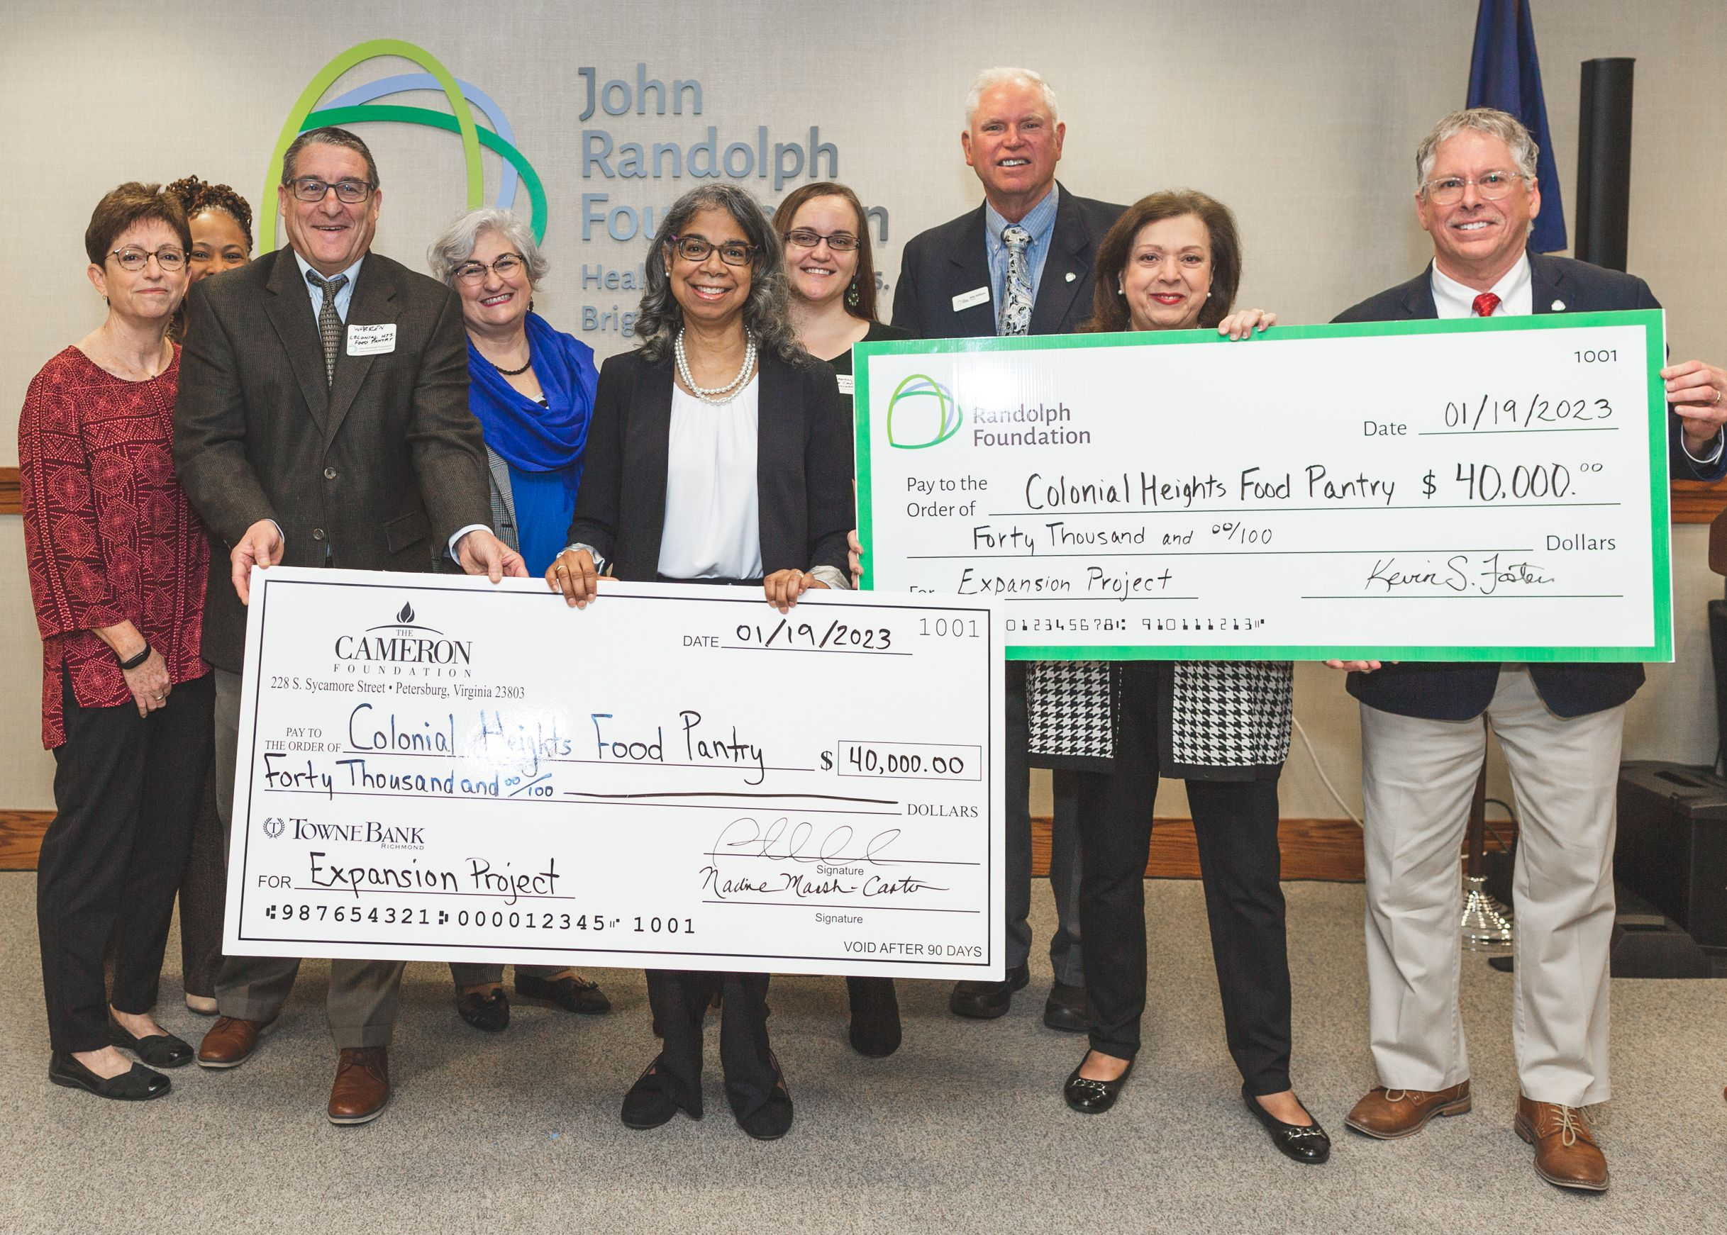
From left: Abby Lynch, CHFP Board Chair; Valerie Liggins, TCF Senior Program Officer for Community Health; Warren Hammonds, CHFP Executive Director; Risha Stebbins, TCF Senior Program Officer & Director of Communications; Nadine Marsh-Carter, TCF President; Brandy Cramer, TCF Program Officer for Community & Economic Development; Mike Williams, JRF Grant Committee Chair; Elisa Carraway, JRF Board President; Kevin Foster, JRF Executive Director. Photo credit Stephen G. Studios
The Cameron Foundation’s President, Nadine Marsh-Carter, noted, “We see that part of the work that we need to do to foster a culture of health is to address food insecurity, and in its larger facility, the Colonial Heights Food Pantry will be able to reach even deeper into the community to answer these needs.”
This expansion will strengthen the CHFP’s commitment to the well-being of its community – as additional space for food storage and food access will result in serving more, and new space for client services will provide opportunities to enhance the lives of those served.

"Expanding our space presents the opportunity for CHFP to have more available client services and client enrichment opportunities within our facility. Referral and resource partners will be able to utilize our facilities for the improvement of our clients' livelihoods and give CHFP the opportunity to arrange enrichment programs for the betterment and well-being of our clients and our community," says Abby Lynch the pantry’s Board President.
The pantry anticipates all construction and expansion plans will be completed later this spring, with occupancy slated for April or May.
The Colonial Heights Food Pantry is a 501c3 nonprofit providing hunger relief in the city of Colonial Heights and some surrounding communities. For additional information visit www.chfoodpantry.org.

###

